SHAKLEE SPRING EXTRAVAGANZA

THIS ANNUAL LUNCHEON WAS STARTED IN 1977 AS A WOMAN’S LUNCHEON,
BUT IS NOW FOCUSED ON BOTH MEN AND WOMEN
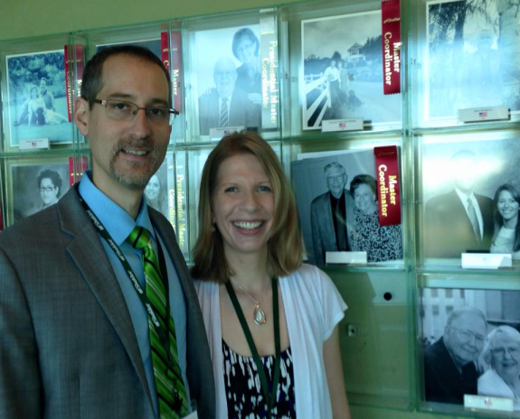

Saturday, May 7, 2016
9:00 a.m. - 1:30 p.m.

Sheraton Minneapolis West
12201 Ridgedale Drive (SE corner of Ridgedale shopping center)
Minnetonka, MN phone: 952-544-6282
Hosted By-
Twin Cities Area Masters

GUEST SPEAKERS – DR. DAVID & REBECCA COLBY, Sr. Directors
DAVID is a professor with a doctorate in Pharmacy as well as a PhD in Chemistry. He teaches classes on dietary supplements at the University of Mississippi and has authored over 25 Scientific Peer-Reviewed papers. Some of his research from his laboratory has been commercialized and reported in the Wall Street Journal!! He also serves on the Shaklee Field Science Advisory Committee. David KNOWS A LOT ABOUT WHAT MAKES FOR A QUALITY SUPPLEMENT and he is going to teach us what to look for and what to avoid.

REBECCA, who has a Masters in Music Therapy, has decided to be a stay-at-home Mom and pursue a Shaklee career. They have earned a Director trip to CA and just received their Shaklee bonus car. She will share why they chose Shaklee and how they are growing their business.

Enjoy an entertaining and educational time where you will learn how to:
- Attain Better Health for your families and
- Have a Non-Toxic “Go Green” home and
- Achieve the Freedom of Time and Money
_ _ _ _ _ _ _ _ _ _ _ _ _ _ _ _ _ _ _ _ _ _ _ _ _ _ _ _ _ _ _ _ _ _ _ _ _ _ _ _ _ _ _ _ _ _ _ _ _ _ _ _ REGISTER EARLY TO GUARANTEE ATTENDANCE
(CHECKS WILL BE HELD WITHOUT CASHING UNTIL 4/20/2016)
Make checks payable to - Minneapolis Master’s Fund
Please mail this form to:
C & J Hoffmann Enterprises, Inc.
Joyce Hoffmann, 1350 Morningview Drive, Mound, MN 55364 Mail by April 22th, 2016
Reserve a block of 5 by April 10th to receive a $5.00 discount , a table reserved for 10 is discounted $10.00
There will be assigned seating, so if you wish to sit with your friends, you may want to secure a table for ten.
I would like to order __________ # tickets @ $ 27.50 each for a total of $____________________
SPECIAL MEAL REQUESTS: ________# vegetarian or _________# gluten free
Check #: ________________ Amount: $_______________ (No Refunds)
Name __________________________________________________________________________
Address_________________________________________________________________________
City ___________________________________ State ____________ Zip __________________
Phone #__________________________ Email ________________________________________

Please enclose a self addressed, stamped envelope for return of your tickets.

