LEADERSHIP SUMMIT 2019
January 19th

This year’s agenda will focus on:
- Network Marketing
- Building a strong, thriving organization
- Power of Lifestyle

- Success Stories

Building depth & a team
- Expanding your dream
Guest Speakers Include:

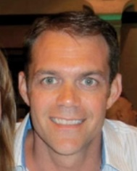
Shawn Gray, Presidential Master Coordinator
Shawn and his wife Carmen have been in networking marketing since 1996. Like many people, Shawn was skeptical in the beginning. He was finishing up degrees in commercial aviation and business. At his wife’s urging, they decided to start a part-time network marketing business. They earned their first million dollars in the industry before age 30 and were in the top income earners in their first company, Excel Communications.

After understanding the reasons behind Roger Barnett purchasing Shaklee Corporation in 2004 they decided to take part in the rebranding of Shaklee in the US and help lead its global expansion. In 2012 and 2013 Shawn & Carmen were named both "Distributors of the Year" and "Leaders of the Year" for Shaklee Corporation USA and have been fortunate enough to create a seven-figure annual income. They have created a system that allows partners worldwide to benefit from the power of Shaklee and the power of a great TEAM!

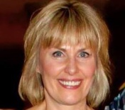
Jennifer Glacken, Senior Master Coordinator
Mind set, leadership, sponsoring, and building in depth are the key skills she works with her team to embrace. As she has coached and mentored her team to focus on these skills, they have become leaders developing leaders who develop leaders.

Scheduled Times:

Registration: 8:00 am -

Event: 9:00 am - 4:00 pm
Location:
Holiday Inn 1000 Busse Rd.
Elk Grove, IL 60007
Regular Ticket Pricing: 1-4 tickets: $30.00 ea 5+ tickets: $25.00 ea
Door Ticket Pricing: 1-4 tickets: $35.00 ea 5+ tickets: $30.00 ea

Reservations: 847.437.6010 Room rate: $79 Code: SHK
www.glackenhealth.com/events.html

facebook: /glackenhw
twitter: @glackenhealth
web: glackenhealth.com

